We need an html template and a text template for each file name.
________________________________________________________________________________
Leave the Header and Footer as-is – swap out cover image for SSW# 100
________________________________________________________________________________
Current Header:
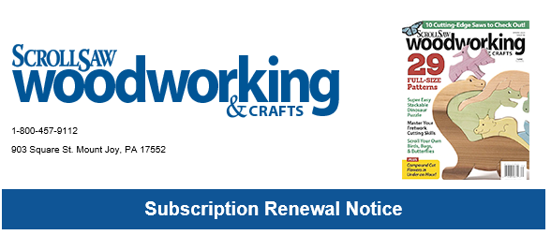

___________________________________________________________________________________
Current Footer:
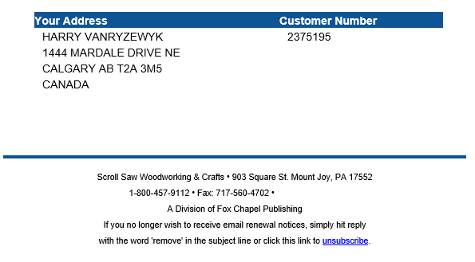

____________________________________________________________________________________

File name: Renewal_SSWC_25SE1
<<Header>>
Hi [[FNAME]],
What was the last piece you scrolled where you stepped back and said, “I made this!”? That feeling never gets old, does it?
Your Scroll Saw Woodworking & Crafts subscription ends with the [[EXPDATE ]] issue, and with it goes something special we’ve reserved just for you.
Right now, you still have access to:
✓ Fresh patterns and projects in each full-color issue, delivered right to your door
✓ Step-by-step photo instructions from master woodworkers
✓ Tool reviews and expert techniques not found elsewhere
✓ The scrolling community you’ve been part of there in [[CITY]]
But here's what you need to know, [[FName]]:
When you renew for 2 years today, you’ll receive exclusive rewards that aren’t available anywhere else:
Your “RENEW40” Discount Code: Save 40% on any book or pattern order – Up to $500 retail value. That’s a possible $200 in savings on the woodworking resources you want most!
Renew for two years online and get this added bonus valued at $47! FREE Digital 3-Pack: three exclusive scroll saw downloads packed with printable patterns, detailed project instructions, and expert tips and techniques!
<<insert bonus photo>>

[🪵 SECURE MY BONUSES & RENEW NOW →] scrollsawer.com/renew This should be on a red bar similar to current template.
Renewing online is quick and easy! You can still opt for a 1-year subscription, but think about it… Most scrollers spend $300+ yearly on patterns and books. Your 40% discount code alone can save you up to $200! Meanwhile, your subscription keeps those projects coming so you can keep creating those “I made this” moments.
[[FNAME]], you’ve been an important part of the Scroll Saw Woodworking & Crafts family. Don’t let anything stand between you and your next masterpiece.

<<Footer>>

Join thousands of other scroll saw enthusiasts on SSW’s social media accounts!
<<insert logs with embedded links?>>

File name: Renewal_ SSWC_25SE2
<<Header>>
Dear [[FNAME]],

Two weeks ago, we reserved something special for you — but time’s running out. Your Scroll Saw Woodworking & Crafts subscription is ending with the [[EXPDATE ]] issue, and I wanted to make sure you didn't miss this.
Here’s what’s at stake:
When friends admire your latest project, it reminds you that’s what Scroll Saw Woodworking & Crafts is all about. We’d hate for anything to interrupt those moments.
Your 2-Year Renewal Package consists of:
✅ 8 issues of Scroll Saw Woodworking & Crafts containing ready-to-use patterns, expert tips and techniques, and step-by-step instructions and projects
✅ RENEW40 Discount Code: Save 40% on pattern and book orders – Up to $200 savings! (magazines excluded)
✅ FREE Digital 3-Pack: Three exclusive scroll saw downloads packed with printable patterns, detailed project instructions, and expert tips and techniques – a $47 value!
<<insert bonus photo>>

[YES, SECURE MY RENEWAL REWARDS →] <<scrollsawer.com/renew button
Renew online for fastest service. It’s guaranteed secure and you get your bonus coupon and digital content immediately.
Scrollers who renew in [[CITY]] can use their RENEW40 code to stock up on up to $500 worth of patterns and books and save up to $200. That savings alone pays for the subscription many times over.
Let’s keep those “I made this” moments coming. Renew today.
Shannon Flowers
Circulation Manager, Scroll Saw Woodworking & Crafts
P.S. You can renew for one year at the low price of [[AMOUNT1]], but the 40% discount code comes ONLY with a 2-year renewal. For just [[AMOUNT3]] you get 8 issues PLUS Your 40% discount code, PLUS Your free Digital 3-Pack!

<<Footer>>
Join thousands of other scroll saw enthusiasts on SSW’s social media accounts!
<<insert logs with embedded links?>>

File name: Renewal_ SSWC_25SE3
<<Header>>

[[FNAME]],
Your very last issue of Scroll Saw Woodworking & Crafts ships in just a few short weeks.
After that? No more patterns. No more step-by-step projects. No more tool reviews or new scrolling techniques.
And you’ll miss out on those exclusive bonuses we’ve been holding for you!
I know you’re busy — maybe you’re in the middle of a project right now. But take 60 seconds to secure your renewal before it’s too late.
If you don’t renew, here’s what you’ll be missing!
❌ Your RENEW40 savings code (40% off patterns and books)
❌ Your FREE Digital 3-Pack (a $47 value)
❌ Your chance to renew at our lowest price of [[AMOUNT3]] for 2 full years of project-packed issues

[⏰ EMERGENCY RENEWAL - CLICK HERE →] scrollsawer.com/renew
[[FNAME]], think about your scrolling journey. Every piece where you’ve proudly said "I made this" started with an idea — often from our pages. Why let that end?
Thousands of scrollers have already chosen to renew this month. Join them now and keep your subscription active.
Your last issue is about to ship out to you. Don't let your subscription lapse. Renew online right now.
Carolyn Willover
Subscription Manager, Scroll Saw Woodworking & Crafts
P.S. Can’t renew online? Call us immediately at 1-800-457-9112. You are still eligible for the discount coupon with a 2-year subscription, but the 3-Pack Digital Bonus is only available for folks who renew online: [LINK]scrollsawer.com/renew

<<Footer>>
Join thousands of other scroll saw enthusiasts on SSW’s social media accounts!
<<insert logs with embedded links?>>
File name: Renewal_ SSWC_25SE5
<<Header>>

Dear [[FNAME]],
By now you’ve likely received your Scroll Saw Woodworking & Crafts [[EXPDATE ]] issue. That will be the last issue you receive if you don’t act quickly!
Here’s the truth: We miss having you in our scrolling family. We want you back. (And I’m sure you miss us, too.)
Your subscription may have lapsed, but you’re still a scroller at heart. You still get that feeling when you finish a piece and say “I made this.” And we’d love to keep fueling those moments.
Not sure you’re ready to make a 2-year commitment? Renew for one year for just [[AMOUNT1]].
But the BEST DEAL is reserved for our 2-year subscribers. For the low price of [[AMOUNT3]], you can enjoy all these benefits:
✓ Resume your subscription immediately. We’ll make sure you don’t miss any issues.
✓ Rejoin the community of scrollers you know
✓ Your “RENEW40” Discount Code which unlocks 40% on any book or pattern order – Up to $500 retail value. That’s a possible $200 in savings!

Renew online and get this added bonus valued at $47! FREE Digital 3-Pack: three exclusive scroll saw downloads packed with printable patterns, detailed project instructions, and expert tips and techniques!
<<insert bonus photo>>
Don’t delay and miss being on our mailing list for the next issue! Renew today and
get back to doing what you love — creating beautiful pieces with your own hands.
[RENEW ME - COME BACK TO THE FAMILY →] scrollsawer.com/renew
[[FNAME]], some subscribers leave and never return. Others take a break and realize they miss the inspiration, the patterns, the techniques, and the community. And miss out on the bonuses.
Which one are you?
Feel that? You’re ready to return and we’re ready to welcome you back.
Looking forward to having you back where you belong.
Carolyn Willover
Magazine Manager
Scroll Saw Woodworking & Crafts
<<Footer>>
Join thousands of other scroll saw enthusiasts on SSW’s social media accounts!
<<insert logs with embedded links?>>

